**Custom Music Player**

This mini project is developed as a custom music player that lets you **ADD, SORT and PLAY** your local music in an organised manner. You can also add your artist and sort your music based on your favourite artists.

**Features**

* Authentication
* Add your local music
* Add your cover picture
* Sort based on Artists
* Play on the web

**Technologies Used**

* HTML – I used HTML default <audio> tag to play the audio on the browser
* CSS – Styling is used for adding more UI to the Application
* PHP – All the database backend communications are done using PHP
* JavaScript – Condition based button generation for a form is implemented using JS
* Mysql – SQL database is used for storing the information.

**Database Schema**

The database *hrithify* is created with the below tables

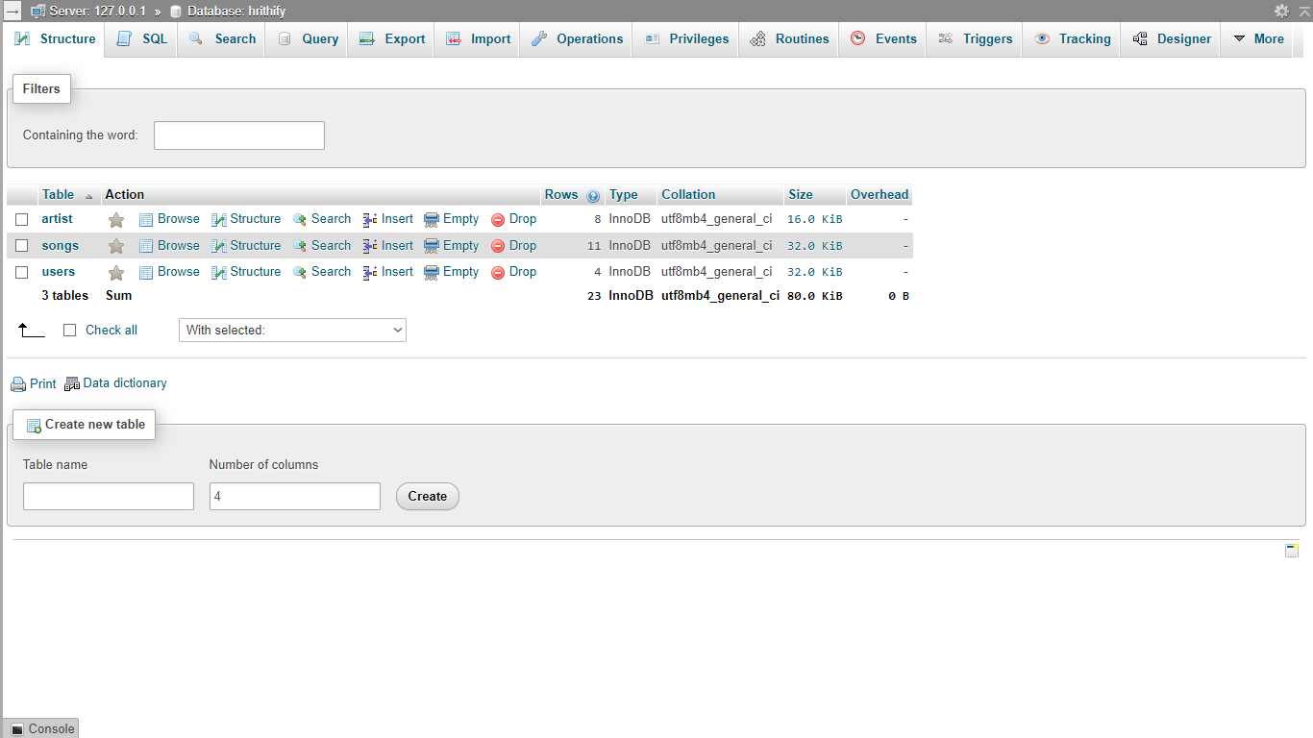

**Tables information**

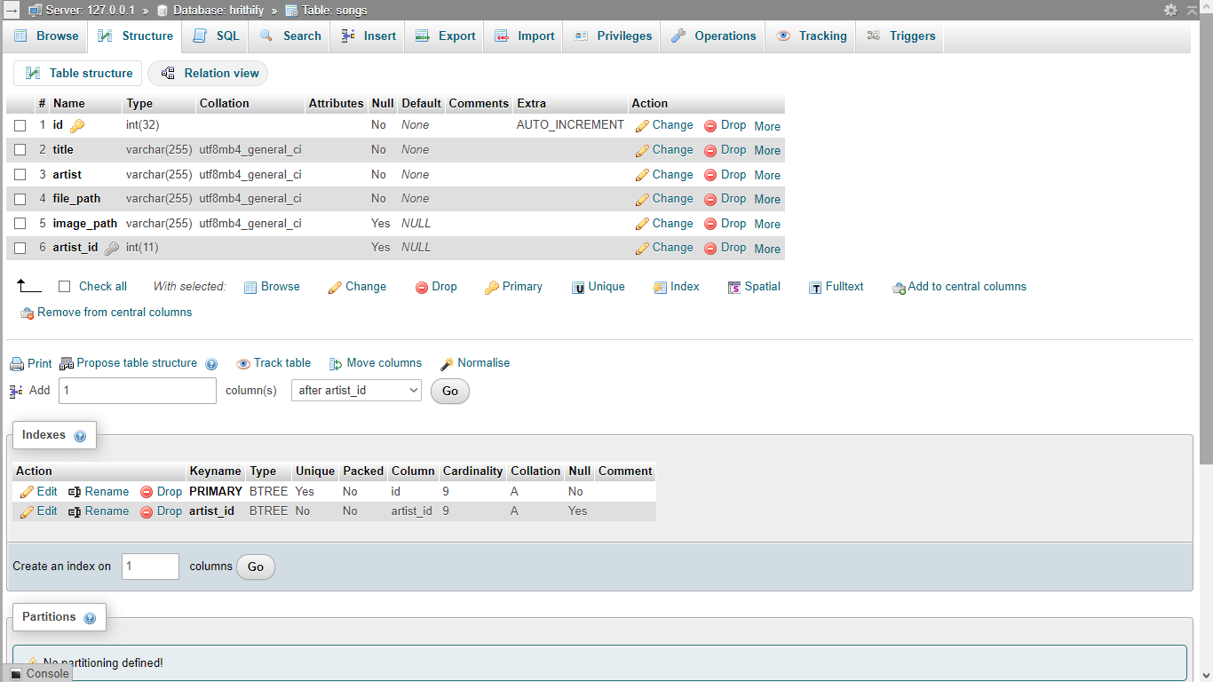 The tables are **songs, artist, users** are created under the database with the below schema that hold the information for the respective data.

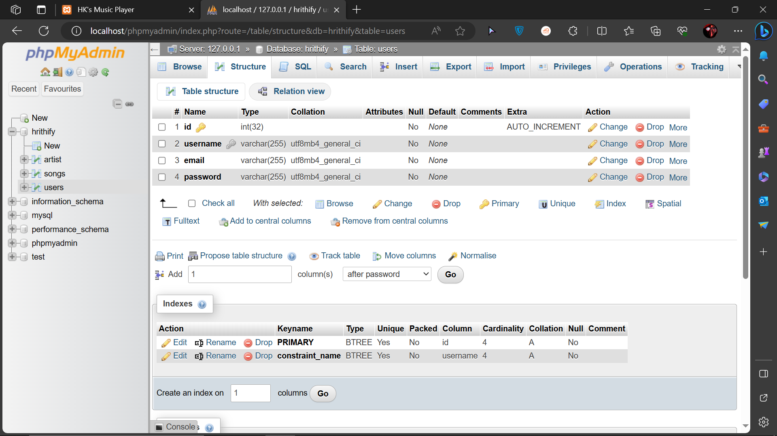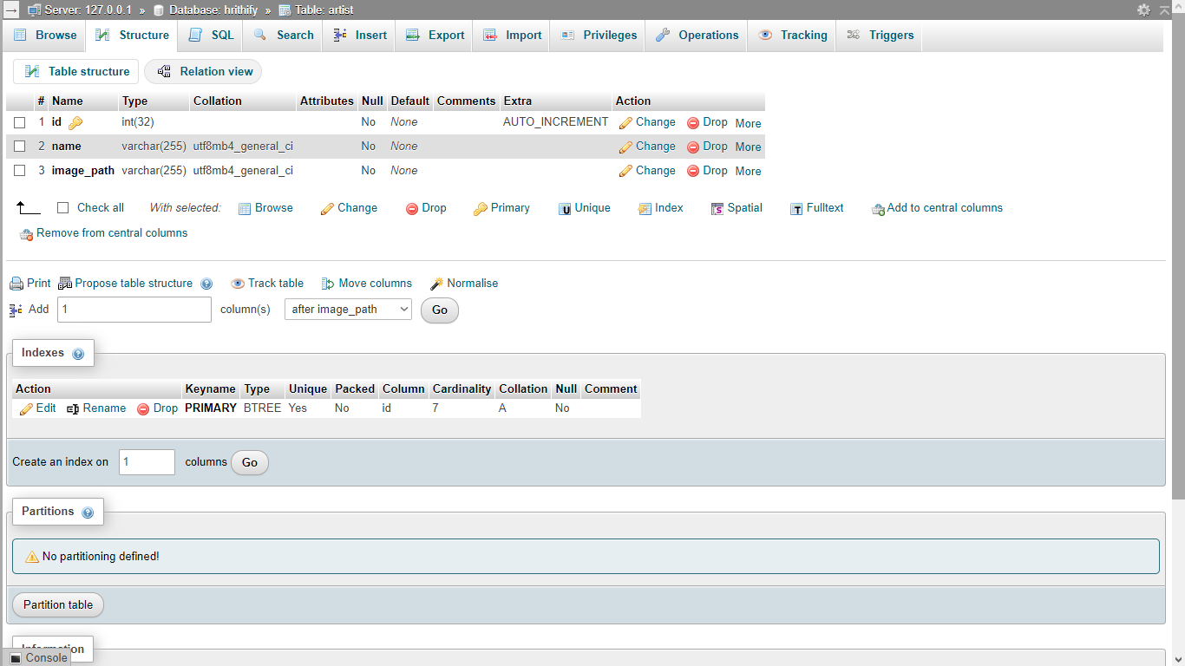 ***Table: songs***

***Table: artist***

***Table: users***

**Frontend Views**

Our project consists of 4 views that are as below:

* User Login
* Upload songs/artists
* Songs
* Artists
* Artist – Songs

The source code and the structure of the views are as below

The entire project is styled by a single html page named *base.html* that has inline css under the <style> tag.

**Base.html :**

<!DOCTYPE html>

<html>

<head>

    <!--Import Google Icon Font-->

    <link href="https://cdn.jsdelivr.net/npm/gotham-fonts@1.0.3/css/gotham-rounded.min.css" rel="stylesheet">

    <link href="https://fonts.googleapis.com/icon?family=Material+Icons" rel="stylesheet">

    <!--Import boostrap.css-->

    <link rel="stylesheet" href="https://stackpath.bootstrapcdn.com/bootstrap/4.4.1/css/bootstrap.min.css"

        integrity="sha384-Vkoo8x4CGsO3+Hhxv8T/Q5PaXtkKtu6ug5TOeNV6gBiFeWPGFN9MuhOf23Q9Ifjh" crossorigin="anonymous">

    <!--Let browser know website is optimized for mobile-->

    <meta name="viewport" content="width=device-width, initial-scale=1, shrink-to-fit=no">

    <style>

        * {

            font-family: "Gotham Rounded Book", "sans-serif";

            padding: 0;

            margin: 0;

            box-sizing: border-box;

        }

        .hero {

            height: auto;

            margin-top: 10px;

            margin-bottom: 10px;

            margin-left: 10px;

            margin-right: 10px;

            display: flex;

            flex-direction: column;

            justify-content: center;

            align-items: center;

            padding: 40px;

            text-align: center;

            background-color: darkgreen;

            color: pink;

        }

        .hero .btn {

            background-color: pink;

            color: darkgreen;

        }

        .page-footer {

            position: absolute;

            bottom: 0;

            width: 100%;

            height: 100px;

            /* You can adjust the height as needed */

            background-color: black;

            color: lightgray;

            padding-top: 60px;

        }

        #img {

            max-width: 300px;

            /* Ensure the image doesn't exceed its container's width */

            height: 300px;

            /* Maintain aspect ratio */

            border: 1px solid #ccc;

            /* Add a border around the image (optional) */

        }

    </style>

</head>

<body>

    <!-- Have students code out a comparable list on their version of this page   -->

    <nav>

        <div class="navbar navbar-expand-lg navbar-dark bg-dark">

            <div class="container">

                <img src="hk.png" alt="Hrithify-Logo" width="50">

                <a class="navbar-brand" href="upform.php"><center><h2>Hrithify</h2></center></a>

                <div>

                    <div class="collapse navbar-collapse" id="navbarNav">

                        <ul class="navbar-nav">

                            <li class="nav-item"><a class="nav-link" href="artists.php">Artists</a></li>

                            <li class="nav-item"><a class="nav-link" href="home.php">Songs</a></li>

                            <li class="nav-item"><a class="nav-link">|</a></li>

                            <li class="nav-item"><a class="nav-link" href="index.php">Log Out</a></li>

                        </ul>

                    </div>

                </div>

            </div>

        </div>

    </nav>

    <!-- <div class="page-footer">

        <div class="container">

            <div class="row">

                <div class="">Spotify Logo</div>

                <div class="">Company content</div>

                <div class="">Communities content</div>

                <div class="">Useful links content</div>

                <div class="">Social icons - this one is twice as wide as the other four.</div>

            </div>

        </div>

    </div> -->

    <!-- Compiled and minified JavaScript -->

    <script src="https://code.jquery.com/jquery-3.4.1.slim.min.js"

        integrity="sha384-J6qa4849blE2+poT4WnyKhv5vZF5SrPo0iEjwBvKU7imGFAV0wwj1yYfoRSJoZ+n"

        crossorigin="anonymous"></script>

    <script src="https://cdn.jsdelivr.net/npm/popper.js@1.16.0/dist/umd/popper.min.js"

        integrity="sha384-Q6E9RHvbIyZFJoft+2mJbHaEWldlvI9IOYy5n3zV9zzTtmI3UksdQRVvoxMfooAo"

        crossorigin="anonymous"></script>

    <script src="https://stackpath.bootstrapcdn.com/bootstrap/4.4.1/js/bootstrap.min.js"

        integrity="sha384-wfSDF2E50Y2D1uUdj0O3uMBJnjuUD4Ih7YwaYd1iqfktj0Uod8GCExl3Og8ifwB6"

        crossorigin="anonymous"></script>

</body>

</html>

**USER LOGIN/REGISTER**

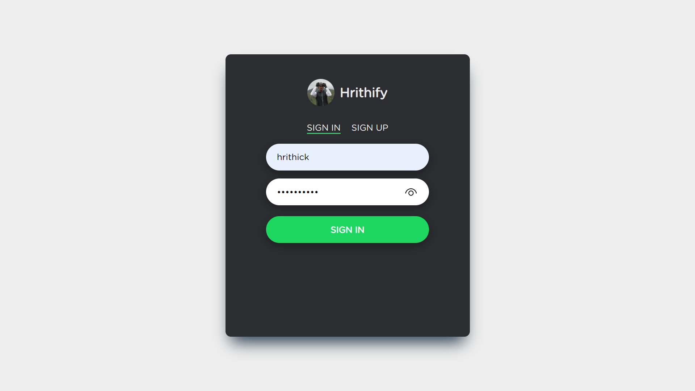

**Login.php:**

<?php

session_start();

$servername = "localhost";

$username = "root";

$password = "";

$dbname = "hrithify";

$conn = new mysqli($servername, $username, $password, $dbname);

if ($conn->connect_error) {

    die("Connection failed: " . $conn->connect_error);

}

if (isset($_POST['login'])) {

    $username = $_POST['username'];

    $password = $_POST['password'];

    // Hash the user-provided password for comparison with the stored hash

    $hashed_password = password_hash($password, PASSWORD_DEFAULT);

    // Perform a SELECT query to retrieve user data based on the provided username

    $sql = "SELECT * FROM users WHERE username = '$username'";

    $result = $conn->query($sql);

    if ($result->num_rows == 1) {

        $row = $result->fetch_assoc();

        if (password_verify($password, $row['password'])) {

            // Password is correct, set session variables or redirect to a welcome page

            $_SESSION['username'] = $row['username'];

            header("Location: home.php"); // Redirect to a welcome page

        } else {

            // Password is incorrect, display an error message

            echo "Incorrect password.";

        }

    } else {

        // No user with the provided username exists, display an error message

        echo "User not found.";

    }

}

$conn->close();

?>

**UPLOAD VIEW**

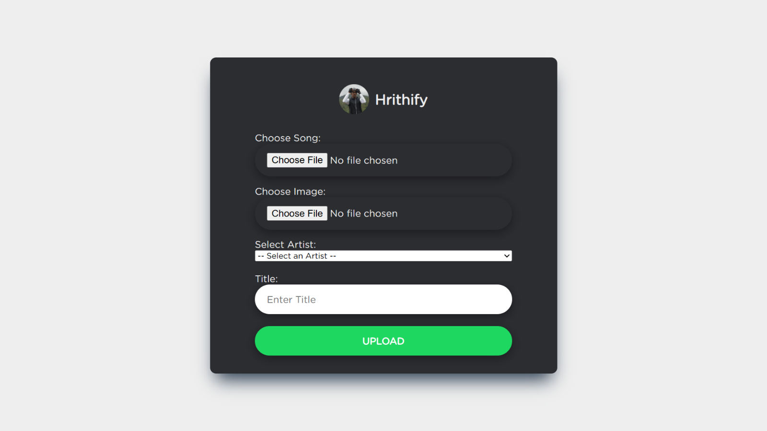

**Upform.php:**

<!DOCTYPE html>

<html>

<head>

    <link href="https://cdn.jsdelivr.net/npm/gotham-fonts@1.0.3/css/gotham-rounded.min.css" rel="stylesheet">

</head>

<body>

    <section>

        <div id="logo">

            <img src="hk.png" alt="Hrithify-Logo" width="50">

            <h1>Hrithify</h1>

        </div>

        <form action="upload.php" method="post" enctype="multipart/form-data" id="SignInFormData">

            <label for="song">Choose Song:</label>

            <input type="file" name="song" id="song" placeholder="Song File" required>

            <label for="image">Choose Image:</label>

            <input type="file" name="image" id="image" required>

            <label for="artist">Select Artist:</label>

            <select name="artist" id="artist">

                <option value="">-- Select an Artist --</option>

                <option value="new">New Artist</option> <!-- Add a new artist option -->

                <?php

                // Database connection

                $servername = "localhost";

                $username = "root";

                $password = "";

                $dbname = "hrithify";

                $conn = new mysqli($servername, $username, $password, $dbname);

                if ($conn->connect_error) {

                    die("Connection failed: " . $conn->connect_error);

                }

                // Retrieve existing artists from the database

                $artistSql = "SELECT id, name FROM artist";

                $artistResult = $conn->query($artistSql);

                if ($artistResult->num_rows > 0) {

                    while ($row = $artistResult->fetch_assoc()) {

                        echo "<option value='" . $row["id"] . "'>" . $row["name"] . "</option>";

                    }

                }

                $conn->close();

                ?>

            </select>

            <div id="newArtistFields" style="display: none;">

                <label for="new_artist_image">Artist Image (for new artist):</label>

                <input type="file" name="new_artist_image" id="new_artist_image">

                <br>

                <label for="artist_name">Artist Name (for new artist):</label>

                <input type="text" name="artist_name" id="artist_name">

            </div>

            <!-- JavaScript to toggle the visibility of the new artist fields -->

            <script>

                document.getElementById('artist').addEventListener('change', function () {

                    var newArtistFields = document.getElementById('newArtistFields');

                    var newArtistImage = document.getElementById('new_artist_image');

                    var artistName = document.getElementById('artist_name');

                    if (this.value === "new") {

                        newArtistFields.style.display = 'block';

                        newArtistImage.setAttribute('required', 'required');

                        artistName.setAttribute('required', 'required');

                    } else {

                        newArtistFields.style.display = 'none';

                        newArtistImage.removeAttribute('required');

                        artistName.removeAttribute('required');

                    }

                });

            </script><br>

            <label for="artist">Title:</label>

            <input type="text" name="title" id="title" placeholder="Enter Title" required>

                <button type="submit" name="Upload" value="Upload">Upload</button>

        </form>

    </section>

</body>

</html>

The above form calls another file named *upload.php*  that connects to the database as below

**Upload.php:**

<?php

// Handle song file upload

$songPath = "music/"; // Specify the path to store songs

$songFileName = basename($_FILES["song"]["name"]);

$songTargetPath = $songPath . $songFileName;

move_uploaded_file($_FILES["song"]["tmp_name"], $songTargetPath);

// Handle image file upload

$imagePath = "img/"; // Specify the path to store images

$imageFileName = basename($_FILES["image"]["name"]);

$imageTargetPath = $imagePath . $imageFileName;

move_uploaded_file($_FILES["image"]["tmp_name"], $imageTargetPath);

// Retrieve artist and title from the form

$artistId = $_POST["artist"];

$newArtistName = $_POST["artist_name"]; // For new artists

$title = $_POST["title"];

// Database connection

$servername = "localhost";

$username = "root";

$password = "";

$dbname = "hrithify";

$conn = new mysqli($servername, $username, $password, $dbname);

if ($conn->connect_error) {

    die("Connection failed: " . $conn->connect_error);

}

// Check if a new artist is being added with an image

if ($artistId === "new") {

    if (!empty($newArtistName) && !empty($_FILES["new_artist_image"]["name"])) {

        $newArtistImage = $_FILES["new_artist_image"];

        // Insert code to upload and store the artist's image

        $artistImagePath = "artist_images/"; // Specify the path to store artist images

        $artistImageFileName = basename($newArtistImage["name"]);

        $artistImageTargetPath = $artistImagePath . $artistImageFileName;

        move_uploaded_file($newArtistImage["tmp_name"], $artistImageTargetPath);

        // Insert the new artist record into the database

        $insertArtistSql = "INSERT INTO artist (name, image_path) VALUES ('$newArtistName', '$artistImageTargetPath')";

        if ($conn->query($insertArtistSql) === TRUE) {

            // Retrieve the newly generated artist ID

            $artistId = $conn->insert_id;

        } else {

            echo "Error creating artist: " . $conn->error;

            $conn->close();

            exit;

        }

    } else {

        echo "New Artist fields are incomplete.";

        $conn->close();

        exit;

    }

}

// Insert the song record

$sql = "INSERT INTO songs (image_path, file_path, artist_id, artist, title)

        SELECT '$imageTargetPath', '$songTargetPath', '$artistId', name, '$title'

        FROM artist

        WHERE id = '$artistId'";

if ($conn->query($sql) === TRUE) {

    echo "New record created successfully";

    header("Location: home.php");

} else {

    echo "Error: " . $sql . "<br>" . $conn->error;

}

// Close the database connection

$conn->close();

?>

**Upform.html:**

        <form action="upload.php" method="post" enctype="multipart/form-data" id="SignInFormData">

            <label for=""Image>Choose Song: </label>

            <input type="file" name="song" id="song" placeholder="Song File" required>

            <label for=""Image>Choose image: </label>

            <input type="file" name="image" id="image"  required>

            <input type="text" name="artist" id="artist" placeholder="Artist Name" required>

            <input type="text" name="title" id="title" placeholder="Title" required>

            <button type="submit" name="Upload" value="Upload">Upload</button>

        </form>

    </section>

</body>

It uses the above form for collecting the data

**SONGS VIEW**

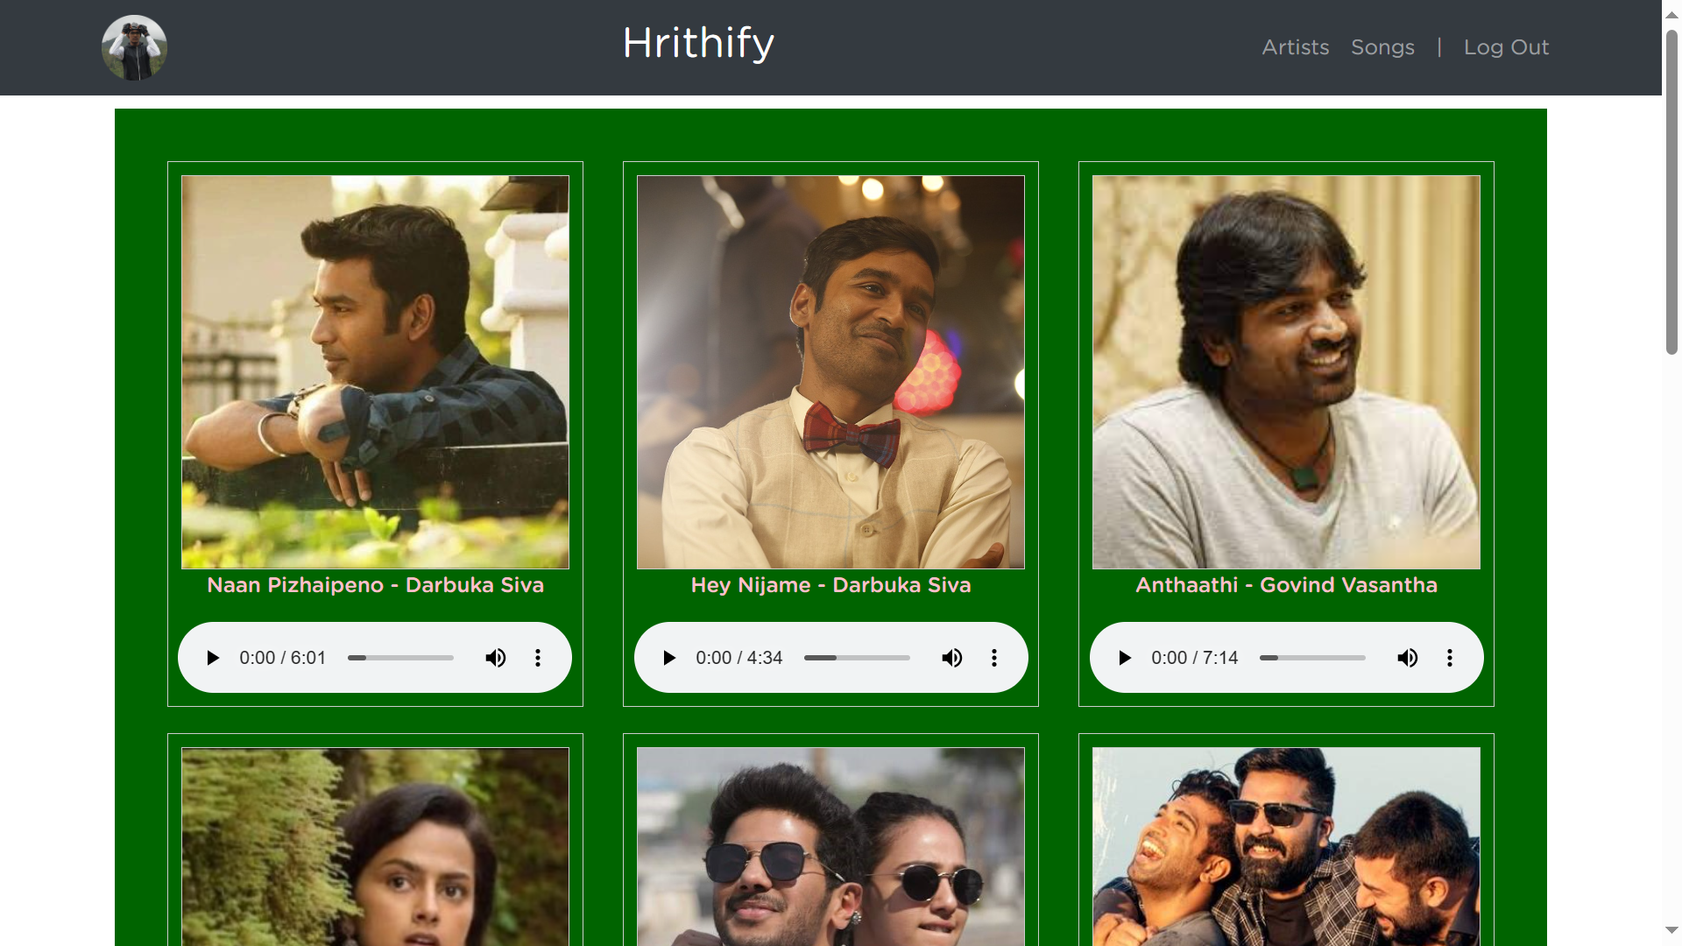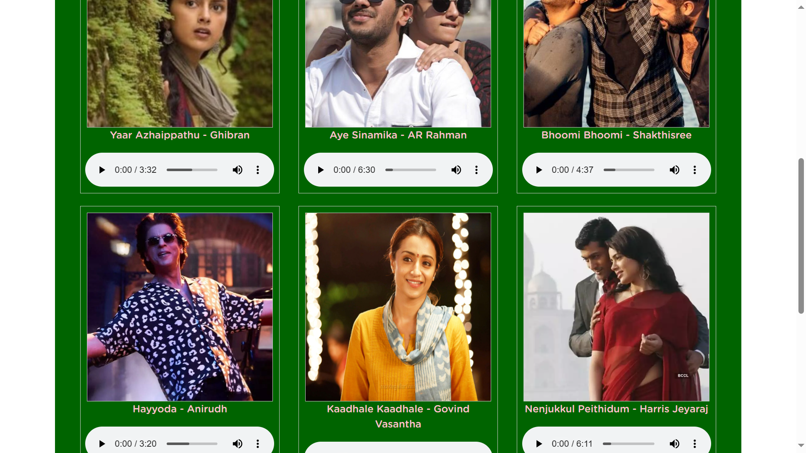

The songs are retrieved from the SQL database and then displayed in the HOME/SONGS page through the below code.

**Songs.php:**

<link href="https://cdn.jsdelivr.net/npm/gotham-fonts@1.0.3/css/gotham-rounded.min.css" rel="stylesheet">

<?php

$servername = "localhost";

$username = "root";

$password = "";

$dbname = "hrithify";

$conn = new mysqli($servername, $username, $password, $dbname);

if ($conn->connect_error) {

    die("Connection failed: " . $conn->connect_error);

}

// Fetch and display songs

$sql = "SELECT id, title, artist, file_path, image_path FROM songs";

$result = $conn->query($sql);

$songs = []; // Create an array to hold song data

if ($result->num_rows > 0) {

    while ($row = $result->fetch_assoc()) {

        // Store song data in an array

        $song = [

            'image_path' => $row['image_path'],

            'audio_id' => $row['id'],

            'title' => $row['title'],

            'artist' => $row['artist']

        ];

        // Add the song to the $songs array

        $songs[] = $song;

    }

}

 else {

    echo "No songs found.";

}

$conn->close();

?>

<style>

    .gotham-font {

        font-family: 'Gotham Rounded', sans-serif;

        /* Add any additional styles you want here */

    }

</style>

*Songs.php* uses another php file named *audio.php* that aids in retrieving the audio

**Audio.php:**

<?php

// Connect to the database

$servername = "localhost";

$username = "root";

$password = "";

$dbname = "hrithify";

$conn = new mysqli($servername, $username, $password, $dbname);

if ($conn->connect_error) {

    die("Connection failed: " . $conn->connect_error);

}

// Get the song ID from the query parameter

if (isset($_GET['id'])) {

    $song_id = $_GET['id'];

    // Fetch the file_path for the selected song

    $sql = "SELECT file_path FROM songs WHERE id = $song_id";

    $result = $conn->query($sql);

    if ($result->num_rows > 0) {

        $row = $result->fetch_assoc();

        $file_path = $row['file_path'];

        // Set the appropriate headers for audio playback

        header('Content-Type: audio/mpeg');

        header('Content-Length: ' . filesize($file_path));

        // Output the audio file content

        readfile($file_path);

    }

}

$conn->close();

?>

**Template.php:**

<body>

    <?php

    include 'songs.php';

    ?>

    <div class="container">

        <div class="hero center-text">

            <div class="song-container">

                <?php foreach ($songs as $song) { ?>

                    <div class="song">

                        <img id="img" src="<?php echo $song['image_path']; ?>" alt="Cover Art">

                        <p class="gotham-font">

                            <?php echo $song['title']; ?> -

                            <?php echo $song['artist']; ?>

                        </p>

                        <!-- Custom audio controls -->

                        <div class="custom-audio-controls">

                            <audio controls class="custom-audio" data-audio-id="<?php echo $song['audio_id']; ?>">

                                <source src="audio.php?id=<?php echo $song['audio_id']; ?>" type="audio/mpeg">

                                Your browser does not support the audio element.

                            </audio>

                        </div>

                    </div>

                <?php } ?>

            </div>

            <br>

        </div>

    </div>

</body>

The *template.php* file gets the data from *songs.php* and displays them using the html template.

**ARTIST VIEW**

**

**Artists.php:**

<body>

    <?php

    include 'base.html';

    $servername = "localhost";

    $username = "root";

    $password = "";

    $dbname = "hrithify";

    $conn = new mysqli($servername, $username, $password, $dbname);

    if ($conn->connect_error) {

        die("Connection failed: " . $conn->connect_error);

    }

    // Fetch a list of artists

    $sql = "SELECT * FROM artist";

    $result = $conn->query($sql);

    if ($result->num_rows > 0) {

        $artists = array();

        while ($row = $result->fetch_assoc()) {

            $artists[] = $row;

        }

    }

    $conn->close();

    ?>

    <div class="container">

        <div class="hero center-text">

            <div class="song-container">

                <?php foreach ($artists as $artist) { ?>

                    <div class="song">

                        <a href="artist.php?artist_id=<?php echo $artist['id']; ?>">

                            <img id="img" src="<?php echo $artist['image_path']; ?>" alt="Cover Art">

                        </a>

                        <p class="gotham-font">

                            <?php echo $artist['name']; ?>

                    </div>

                <?php } ?>

            </div>

            <br>

        </div>

    </div>

</body>

**ARTIST-SONGS VIEW**

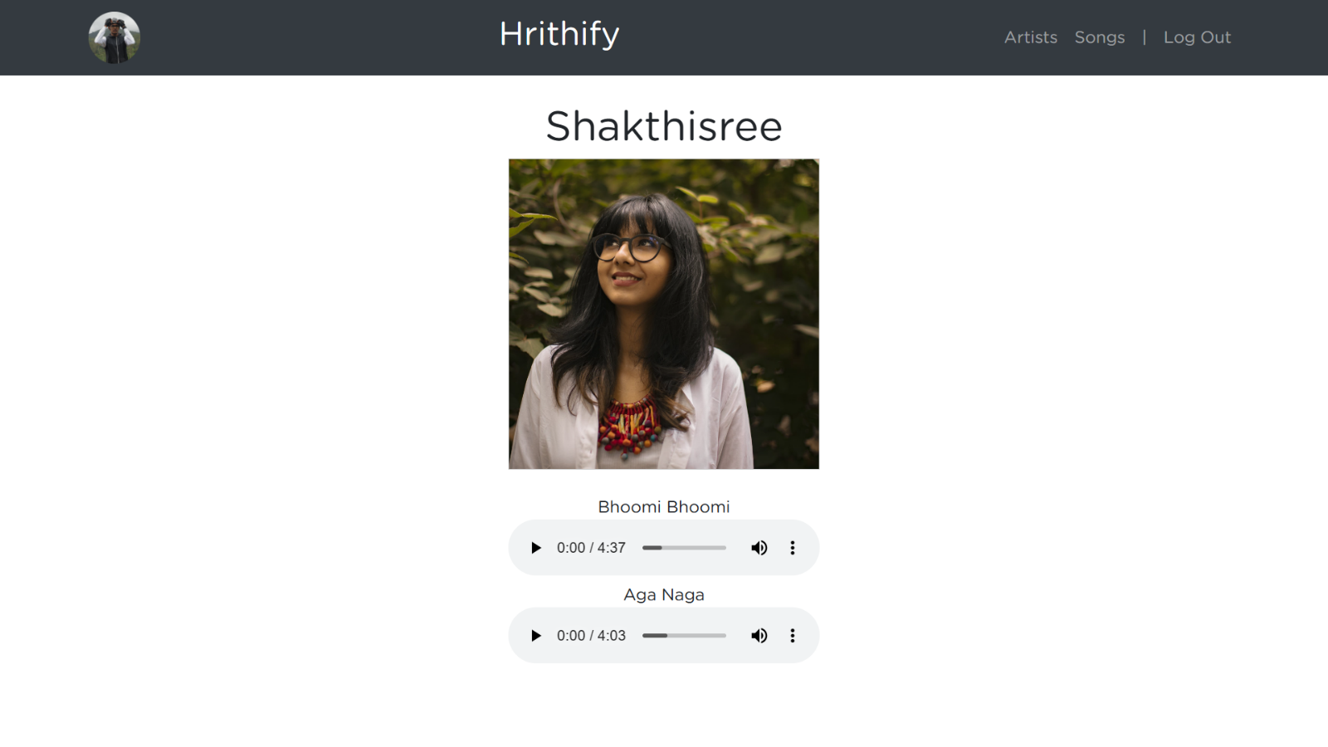

As we select the artist name, we use *header* to pass it to another file that displays the songs of each artist individually. This is handled by the below file *artist.php*

**Artist.php:**

<?php

include 'base.html';

include 'songs.php';

$servername = "localhost";

$username = "root";

$password = "";

$dbname = "hrithify";

$conn = new mysqli($servername, $username, $password, $dbname);

if ($conn->connect_error) {

    die("Connection failed: " . $conn->connect_error);

}

if (isset($_GET['artist_id'])) {

    $artist_id = $_GET['artist_id'];

    // Fetch artist information

    $artist_sql = "SELECT * FROM artist WHERE id = $artist_id";

    $artist_result = $conn->query($artist_sql);

    if ($artist_result->num_rows > 0) {

        $artist = $artist_result->fetch_assoc();

    }

    // Fetch songs for the selected artist

    $songs_sql = "SELECT * FROM songs WHERE artist_id = $artist_id";

    $songs_result = $conn->query($songs_sql);

    if ($songs_result->num_rows > 0) {

        $songs = array();

        while ($row = $songs_result->fetch_assoc()) {

            $songs[] = $row;

        }

    } else {

        echo "No songs found for this artist.";

    }

} else {

    echo "Invalid artist ID.";

}

$conn->close();

?>

**Project Structure:**

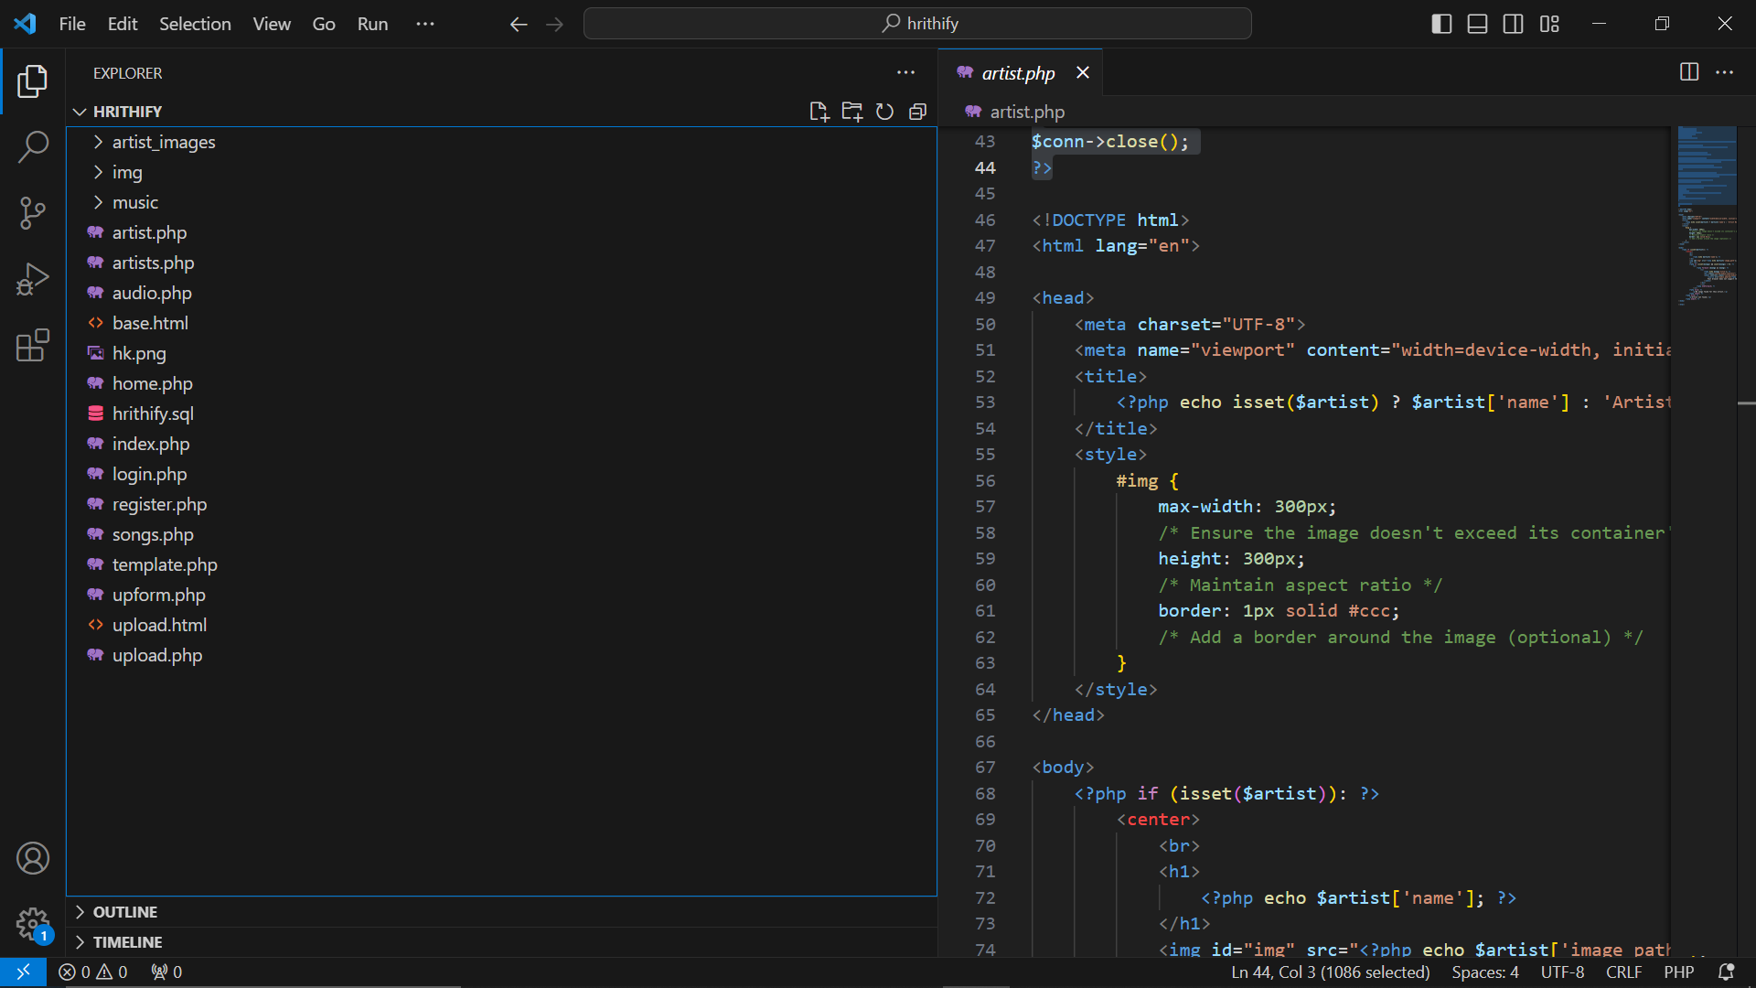

The project makes use of the paths *“/music”* that holds the music files that are uploaded by moving the .mp3 files to this folder. The same procedure is used to display the images that are under the paths *“/img”* and *“/artist_images”* that holds the cover images and artist images respectively.

**USER MANUAL**

1. Go to the path: *“localhost/hrithify”*
2. In **Sign Up**, Register yourself as new user
3. You will be redirected to the **Sign In** page
4. You will see the **Home page** that has all the Music files
5. In the *navigation bar*, you can see the **Artist page** that holds the information about all the artists.
6. When you click the *image of the artist*, you will see the songs that are composed by the respective artists.
7. When you click the **Hrithify** button on the navigation bar, you will see the *form for uploading local music and artist information.*
8. If the *artist is new*, you will be asked to **add the artist information** along with the song information.
9. After you upload the form, you will see your song in the songs page
10. When you click the **logout** on the nav-bar, you can see your account logged out from the application.